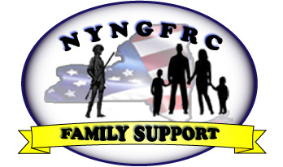

The New York National Guard Family Readiness Council, Inc. (NYNGFRC) is pleased to announce the awarding of two of $500 College Scholarships for the 2017-2018 academic year. The Scholarships may be used for expenses incurred while attending an accredited college or university.

These Scholarships will be awarded to children or spouses of the New York Organized Militia who meet the eligibility requirements. Once they complete an application and provide other required information, they will be considered for a Scholarship.

The application and other information may be found on the NYNGFRC website www.nyfrc-inc.org.

In order to be eligible to receive a scholarship, you must meet the following requirements:

* Be a dependent unmarried child under the age of 23 of a member of the New York Organized Militia **OR**
* The spouse of a member of the New York Organized Militia
* Be a graduating high school senior attending an accredited college or university in Fall 2017 **OR**
* Be enrolled at an accredited college or university returning Fall 2017
* Be enrolled in DEERS (Defense Enrollment Eligibility Reporting System) and have a current ID card
* Provide a completed Scholarship Application and required enclosures by May 1, 2017.
* You may not be attending a service academy or prep school.

If you have any questions, please email them to scholarship@nyfrc-inc.org

**New York National Guard Family Readiness Council, Inc.**

**595 New Loudon Road, #170**

**Latham, NY 12110**

**nyfrc-inc.org**

**nyfrc-inc.org**

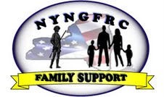New York National Guard Family Readiness Council, Inc.

For Office Use Only

Application for College Scholarship

Last Name First Name Middle Initial

Street Address City State Zip Code

( ) ( )

Home Phone Preferred Phone Email Address

I am a High School Senior and expect to graduate in _____/____/____

High School Name:

Street Address City State Zip Code

Anticipated degree/course of study: ______________________________________

Name of College/University planning to attend:_____________________________________

Street Address City State Zip Code

Have you been accepted? __________ Yes __________ No

I am currently enrolled in college expect to graduate in _____/____/____

Anticipated degree/course of study: ______________________________________

Name of College/University attending: _____________________________________

Street Address City State Zip Code

Have you received or are you scheduled to receive any other scholarships or are you using GI Bill funds for this award year for your college studies? Yes or No. If yes, please specify the name of the award(s):

Do you have a Dependent ID Card? Yes or No. If no, will you have one by the start of school? Yes or No.

Please describe any volunteer or charitable experience you may have, or other interests or activities outside or in school:

What degree do you expect to receive and what are your career goals?

Essay:

On a separate piece of paper, please explain in 300 words or less how having a parent or spouse in the military impacted your decision to attend college.

Applicant’s Name (Printed) Signature Date

Sponsor’s Name (Printed) Signature Date

Please return completed application and required attachments to:

NYNGFRC 595 New Loudon Road, #170, Latham, New York 12110

Checklist for College Scholarship

Incomplete Applications will not be considered

_____ Application completed

_____ I have signed the application

_____ Application signed by sponsor, or if sponsor is deployed, by parent or guardian

_____ Essay of 300 words or less is enclosed (with my name on it)

_____ A Letter of reference is enclosed, you may use a letter that you included with your college application.

_____ I have kept a copy of my application and each of the enclosures